**DRIVER DROWSINESS DETECTION SYSTEM**

## A PROJECT REPORT

***Submitted by***

|  |  |
| --- | --- |
| **SRIRAM K** | **(2017102133)** |
| **SIVA MALAN T** | **(2017102129)** |
| **SELVA KUMAR M** | **(2017102117)** |

# For VI Semester 15UCS607 – TECHNICAL PROJECT

**SETHU INSTITUTE OF TECHNOLOGY**

### (An Autonomous Institution | Accredited with ‘A’ Grade by NAAC)

**PULLOOR, KARIAPATTI-626 115**.

**DEPARTMENT OF COMPUTER SCIENCE AND ENGINEERING**

(Approved Research Center under Anna University, Chennai)

**ANNA UNIVERSITY: CHENNAI 600 025.**

**APRIL 2020**

i

**SETHU INSTITUTE OF TECHNOLOGY**

### (An Autonomous Institution | Accredited with ‘A’ Grade by NAAC)

**PULLOOR, KARIAPATTI - 626 115.**

ANNA UNIVERSITY: CHENNAI 600 025**.**

# BONAFIDE CERTIFICATE

Certified that this project report entitled **“ONLINE SECONDHAND BOOKBUYING & SELLING PORTAL”** is the bonafide work of **SRIRAM K, SIVA MALAN T** and  **SELVA KUMAR M** who carried out the project work under my supervision.

## SIGNATURE SIGNATURE

### Dr.C.CALLINS CHRISTIYANA Mrs.M.MATHINAKANI

**HEAD OF THE DEPARTMENT SUPERVISOR**

Submitted for the 15UCS607 – Technical Project End Semester Examination held on ------------------------

## INTERNAL EXAMINER EXTERNAL EXAMINER

# ACKNOWLEDGEMENTS

### First we would like to thank **GOD** the almighty for giving us the talent and opportunity to complete our project and our **B.E** degree.

We wish to express our earned great fullness to our Honorable Founder and Chairman, **Mr. S. Mohamed Jaleel B.Sc., B.L.,** for his encouragement extended us to undertake this project work.

We wish to thank and express our gratitude to our Chief Executive Officer **Mr. S.**

**M. Seeni Mohideen B.Com., M.B.A.,** Director-Administration, **Mrs. S. M. Nilofer Fathima B.E., M.B.A** Director - R & D, **Mrs. S. M. Nazia Fathima B.Tech., M.E.,** and Joint chief executive officer, **Mr. S. M. Seeni Mohamed Aliar Maraikkayar B.E., M.E., M.B.A.,** for their support in this project.

We would like to thank and express our gratitude to our Principal, **Dr. A. Senthil Kumar B.E., M.E, Ph.D.,** for providing all necessary for the completion of the project. We wish to express our gratitude towards our Vice Principal, **Dr. G.D.Siva Kumar B.E., M.E, Ph.D.,** for his support to our project work.

We wish to express our profound gratitude to our Head of the Department **Dr. C.Callins Christiyana B.E., M.Tech., Ph.D.,** for granting us the necessary permission to proceed with our project.

### We are immensely grateful to our guide, supervisor and overseer **Mrs.M.Mathinakani ,** for encouraging us a lot throughout the course of the project. We render our sincere thanks of his support in completing this project successfully.

We thank our **Parents, Faculty Members, Supporting Staff** and **Friends** for their help extended during these times.

# ABSTRACT

This project is like an e- bookstore website where books can be bought from the comfort of home through the Internet. An online bookstore is a virtual store on the Internet where customers can browse the catalog and select books of interest. User can select many books and those books stored in cart. At checkout time, the items in the shopping cart will be presented as an order. At that time, more information will be needed to complete the transaction. Usually, the customer will be asked to fill the basic details or select a billing address, a shipping address, a shipping option, and payment information such as credit card number.

An online bookstore software projects that acts as a central database containing various books in stock along with their title, author and cost. This project is a website that acts as a central book store. This web project is developed using asp.net as the front end and sql as a back-end. The sql database stores various book related details. A user visiting the website can see a wide range of books arranged in respective categories. The user may select desired book and view its price. The user may even search for specific books on the website. Once the user selects a book , he then has to fill in a form and the book is booked for the user. Online Book Purchase and Sales system is the open source web based project developed with PHP scripting language and open source MYSQL database server. This web application provides huge database of different book collections over the internet where any person can search interested books and purchase it through different payment options where user can send a purchase order to merchant online. User can register himself in the index webpage through registration link as member or book provider both where he can add his personal books to our database for sell. The optimization of this PHP project has done and works successfully without delay at the server. In order to make our web site more attractive and user friendly, we introduced some more features like–

* Provide total information about each and every book and its user ratings by user reviews, by author ratings.
* Provides search engine options based on book type, book Author, Book Name, Publisher name, cost of the book.

**TABLE OF CONTENTS**

## CHAPTER TITLE PAGE NO. NO.

ACKNOWLEDGEMENTS iii

ABSTRACT iv

LIST OF FIGURES vi

LIST OF TABLES vii

LIST OF ABBREVIATIONS vii

1. INTRODUCTION
   1. Overview of the Project 1
   2. Motivation for the Problem 1
   3. Objective of Project 1
2. LITERATURE SURVEY 4
3. REQUIRMENY ANALYSIS
   1. Introduction 6
   2. Hardware and specifications 6
   3. software and Specifications 6
   4. languages used 6
4. SYSTEM ANALYSIS
   1. Languages used 7
5. **SYSTEM DESIGNING 10**
   1. System designing 10
   2. Data flow diagram 10

6 CODING 12

7 TESTING AND MAINTAINANCE 17

8 DEPLOYMENT AND MAINTENANCE 19

9 CONCLUSIONS 19

10 REFERENCES 20

# LIST OF FIGURES

|  |  |  |
| --- | --- | --- |
| **S. No.** | **Figure Description** | **Page No.** |
| 1. | 1.1 overview of the project | 3 |
| 2. | 5.1System desiging | 11 |
| 3. | 5.2Data flow diagram | 11 |
| 4. | 5.3Admin login | 12 |
| 5. | 6.2Home page | 16 |
| 6. | 6.4 Register Page | 17 |
| 7.. | 6.4 Sign In Page | 17 |

# LIST OF TABLES

|  |  |  |
| --- | --- | --- |
| **S. No.** | **Abbreviations** | **Page No.** |
| 1. | 4.3.1Log in Table | 8 |
| **2.** | 4.3.2Admin Table | 8 |
| **3.** | 4.3.3Category Table | 9 |
| **4.** | 4.3.4Sub-Category Table | 9 |
| **5.** | 4.3.5Book Table | 9 |
| **6.** | 7.1.1.Test case for Home Test | 16 |
| **7.** | 7.1.2.Test case for Register Test | 17 |
| **8.** | 7.1.3.Test case for Sign In Test | 18 |

# LIST OF ABBREVIATIONS

|  |  |  |
| --- | --- | --- |
| **S. No.** | **Abbreviations** | **Description** |
| **1.** | PHP | Hypertext Pre-processor |
| **2.** | HTML | Hypertext Markup Language |
| **3.** | RAM | Random Access Memory |
| **4.** | DBMS | Database Management System |
| **5.** | RDBMS | Relational Database Management System |
| **6.** | GUI | Graphical User Interface |
| **7.** | DFD | Data Flow Diagram |
| **8.** | ER-D | Entity Relationship Diagram |
| **9.** | HTTP | Hyper Text Transfer Protocol |
| **10.** | TCP | Transmission Control Protocol |
| **11.** | IP | Internet Protocol |
| **12.** | FTP | File Transfer Protocol |
| **13.** | APP | Application |

* 1. **Overview of the Project:**

# INTRODUCTION

This project is like an e- bookstore website where books can be bought from the comfort of home through the Internet. An online bookstore is a virtual store on the Internet where customers can browse the catalog and select books of interest. User can select many books and those books stored in cart. At checkout time, the items in the shopping cart will be presented as an order. At that time, more information will be needed to complete the transaction. Usually, the customer will be asked to fill the basic details or select a billing address, a shipping address, a shipping option, and payment information such as credit card number.

The system will be a website where the users will come on and buy and sell their respective books on the site. The system uses numerous technologies like HTML, CSS, PHP, JavaScript, jQuery, Bootstrap, SQL amongst others to bring the whole project together.HTML provided the basic framework for the pages. CSS was used for the styling and designing the pages. JavaScript, Jquery. Bootstrap was mainly needed to allow the website to be fully responsive. PHP and SQL were needed to allow the functionalities such as sessions and allow database connectivity.

An online bookstore software projects that acts as a central database containing various books in stock along with their title, author and cost. This project is a website that acts as a central book store. This web project is developed using asp.net as the front end and sql as a back-end. The sql database stores various book related details. A user visiting the website can see a wide range of books arranged in respective categories. The user may select desired book and view its price. The user may even search for specific books on the website. Once the user selects a book , he then has to fill in a form and the book is booked for the user. Online Book Purchase and Sales system is the open source web based project developed with PHP scripting language and open source MYSQL database server. This web application provides huge database of different book collections over the internet where any person can search interested books and purchase it through different payment options where user can send a purchase order to merchant online. User can register himself in the index webpage through registration link as member or book provider both where he can add his personal books to our database for sell. The optimization of this PHP project has done and works successfully without delay at the server. In order to make our web site more attractive and user friendly, we introduced some more features like–

* Provide total information about each and every book and its user ratings by user reviews, by author ratings.
* Provides search engine options based on book type, book Author, Book Name, Publisher name, cost of the book.

1

## Motivation of the problem:

## Building an online book reselling website provides an alternative means of ecommerce for selling school books and vulnerable books for the students and remaining people. The system also comes with a great benefit which is that it also provides an enquiry of books and also the uploading and purchasing book with a single click on the button. It also provides the user to enquire about the books through message.

## The objective is to develop a fully functional online book selling website to allow student to sell and buy books and obtain the full utilisation of the books. To further make the system complete an enquiry system is put into place to determine if a buyer or up loader wants to interact with the admin or the user and providing the confirmation regarding the book to be purchased or

## uploaded.

## Objective of Project:

**Efficiency –** We can say that this is an efficient system since it consumes very less power yet provide more useful information.

**Accuracy –** The system will provide more accurate results under any circumstance so we can trust the result of the system.

**Performance –** The system improves the performance of the driver since the system always monitor the driver who drives the vehicle.

**Cost –** This system is very cost efficient system, since it uses very simple low cost devices like camera and buzzer.

**Protective –** This system will protect the driver who drives the vehicle as well as the other people on the road by preventing the accidents.

**Implementation –** This system contains less complicated components which makes the system to be implemented easily.

**Sustainability –** Once the system is implemented then there will be no need of any maintenances of the system.

## Usefulness/Relevance to the Society:

Now a days peoples are suffer to buy a new books from book shop. so we buy a old books for low cost at old bookselling shop.But some times we not get the exact author book what we need so we searching the old book for many shops with good quality but unfortunately the book was not available in that particular area.And if we have some unneccesary old books in home .we buy that book for very low price but we spent more money to buy a new book

So our project is used to easy way to buy a oldbooks from anywhere through this website and buy your old books with reasonable price .this website is used to reduce our time and save money and buy a good Quality books.

## 2.1 EXISTING SYSTM

# LITERATURE SURVEY

Existing system is a manual one in which users is maintaining books to sell and buy above mention. It is very difficult to manage the transaction and order of the books. Together it doesn‟t allow the user to interact with the admin. It is very difficult to maintain the historical data.

The whole process of transaction and ordering of the book. The order of books is totally dependent on the seller and customer. The site manager is not responsible for the transaction. The books enquiry can also be done by the user. The order of books can easily be done in this site

**2.3 DISADVANTAGES OF THE CURRENT SYSTEM:**

* The user cannot interact with the admin
* A lot of correction work hence delay in giving the results
* A lot of uploading server problem
* It’s very time consuming
* Modification was not possible
* The chances of loss of the order
* No enquiry facility
* Filtering is not easy
* Re-viewing becomes more time consuming

**2.4 PROPOSED SYSTEM:**

This system is used for online advertising the books for sale and purchase. The user can upload the pictures of book along with the price and little description. The enquiry system has been added to this system.

This system provides the administrator with full-fledged facility of removing abusive

books or malicious users. It provides the administrator to add books, remove and contact

the user who have registered to the site. It takes care of authentication of the administrator, user and guest user.

**2.5TECHNICAL FEASIBILITY:**

* + - * The technical feasibility study basically centers on alternatives for hardware, software and design approach to determine the functional aspects of system.
      * This project on Online Book Sell will be platform independent since it is being coded in PHP language (using JavaScript and CSS). HTML is used to create web pages.
      * MySQL database will be used for storing data.
      * Hardware requirements are compatible with all Operating System. Only authorized person will be able to use the website so it would be secure. The system can also be expanded as per the needs of requirement specification.
      * Technical feasibility is concerned with specifying equipment and software that will meets the equipment and goals.
      * The analyst must find out whether current technical resource can be upgraded or
      * Added to in manner that fulfils the request under consideration.
      * The system must be evaluated from the technical point of view first.
      * The assessment of this feasibility must be based on an outline design of the system
      * Requirement in the terms of input, output, programs and procedures.

**2.6 ECONOMIC FEASIBILITY:**

A system can be developed technically and that will be if installed it must still be a good investment for the organization.

Financial benefits must equal or exceed the costs. It is the most frequently used evaluating the effectiveness of proposed system, more commonly known as Benefit analysis.

Benefit analysis is to determine benefits and savings which are expected from candidate system and compare them with cost. If the benefits are more than the cost, the decision is made to design and implement the system.

The cost and benefits may be direct or indirect and tangible or intangible.

**3.Requirement Analysis**

**3.1 INDRODUCTION:**

For the successful development of any project, it is very necessary to study about all the requirements of the project. This requirement may be related to resource, hardware, software, functionalities, etc.

This requirement analysis is as important as the implementation of the project. The requirement analysis basically emphasizes on the listing of the necessary requirements required for the development of the project.

**3.2HARDWARE AND SPECIPICATION:**

PC : Pentium IV

Processor : 1 GHz CPU

RAM : 512 MB

Hard disk : 5 GB

**3.3SOFTWARE AND SPECIPICATION:**

Operating System : Windows 2000/XP/8.1/10

Languages : HTML, PHP, CSS, JavaScript, JQuery Back End : MYSQL

Browser : Opera, Mozilla Firefox, Google Chrome

**3.4 LANGUAGES USED:**

* + - * HTML
      * CSS
      * JAVASCRIPT
      * PHP
      * JQUERY
      * BOOTSTRAP

**4.System Analysis & Design**

**4.1 LANGUAGES USED:**

Modules are the partitions of any project done to ease the task of development. Different modules are designed so that debugging and other development phase gets the easiest implementation.

On a broad perspective the functionalities in the project are constrained depending on whether or not the user is a registered member with the website. Further, the user should also be logged in to enjoy the complete range of the features available.

The different pages of the system are:

* + - Home page
    - Sign in page
    - Welcome page
    - Select Book page
    - Search Page

**4.2 HOME PAGE:**

Our home page show the Sign in and SignUp options. To give any upload or buy any book you have to Sign in to the site and then proceed to the next step.For new users signup is necessary to upload book. The „Sign in‟ option is provided on the home page.

**4.2.1SIGN IN PAGE:**

For unregistered user:

The register page prompts the user to enter their name, email address along with a username and password. The page has validation features implemented to check the format of the email and the format of the first and last names which should be text. The page also checks for the new registrant to have a unique username by checking the database for a match against the existing usernames. It also checks the password typed. It re-verifies the password by re- password method validation used in the page.

For registered user:

If user is already registered then they will be able to give enquire or upload any book by just Sign in on home page. It also allows the user to deal or interact with the admin

**4.2.2 WELCOME PAGE:**

When the user will Sign in he/she will get the option for enquiry and uploading of the book. If the user has already given any posted then they can check their posting by clicking on MyPost option i.e. available on the left-side of the page.

### **4.3.1. DATABASE DESIGN**

|  |  |  |  |
| --- | --- | --- | --- |
| **S.No.** | **Attribute** | **DataType** | **Constraint** |
| 1. | Id | Int | NotNull |
| 2. | Name | Varchar(255) | Not Null |
| 3. | Mobile | Varchar(255) |  |
| 4. | City | Varchar(255) | Not Null |
| 3. | Email | Varchar(255) | Not Null |
| 4. | Password | Varchar(255) | Not Null |

**4.3.2ADMIN PAGE TABLE:**

|  |  |  |  |
| --- | --- | --- | --- |
| **S.No.** | **Attribute** | **Data Type** | **Constraint** |
| 1. | Name | Varchar(255) | Not Null |
| 2. | User Name | Varchar(255) | Not Bull |
| 3. | Email | Varchar(10) | Not Null |
| 4. | Password | Varchar(30) | Not Null |

**4.3.3CATEGORY TABLE**

|  |  |  |  |
| --- | --- | --- | --- |
| **S.No.** | **Attribute** | **Data Type** | **Constraint** |
| 1. | Id | int(5) | Primary Key |
| 2. | C_name | int(5) | Primary key |

**4.3.4SUB CATEGORY TABLE:**

|  |  |  |  |
| --- | --- | --- | --- |
| **S.No.** | **Attribute** | **Data Type** | **Constraint** |
| 1. | Id | int(5) | Primary Key |
| 2. | C_name | int(5) | Primary key |

**4.3.5BOOK TABLE:**

|  |  |  |  |
| --- | --- | --- | --- |
| **S.No.** | **Attribute** | **Data Type** | **Constraint** |
| 1. | Id | Int(30) | Not Null |
| 2. | sub_cat_id | int(15) | Not Null |
| 3. | Cat_id | Varchar(255) | Not Null |
| 4. | b_name | Varchar(255) | Not Null |
| 5. | b_price | Varchar(255) | Not Null |
| 6. | Author | Varchar(255) | Not Null |
| 7. | Pub_year | Varchar(255) | Not Null |
| 8. | Owner_id | Varchar(255) | Not Null |
| 9. | Mobile | Varchar(255) | Not Null |
| 10. | File | Varchar(255) | Not Null |

**5. SYSTEM DESIGNING**

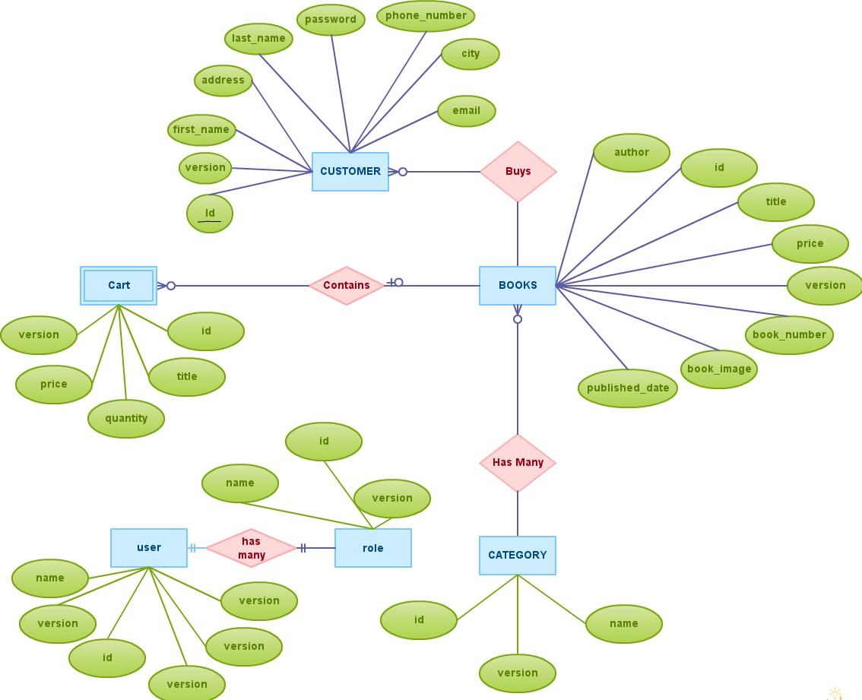

**5.2DATA FLOW DIAGRAM:**

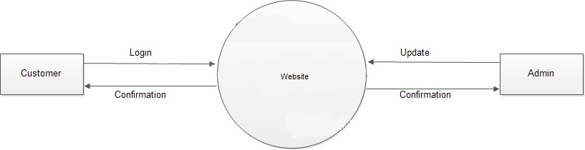

**5.3ADMIN LOGIN:**

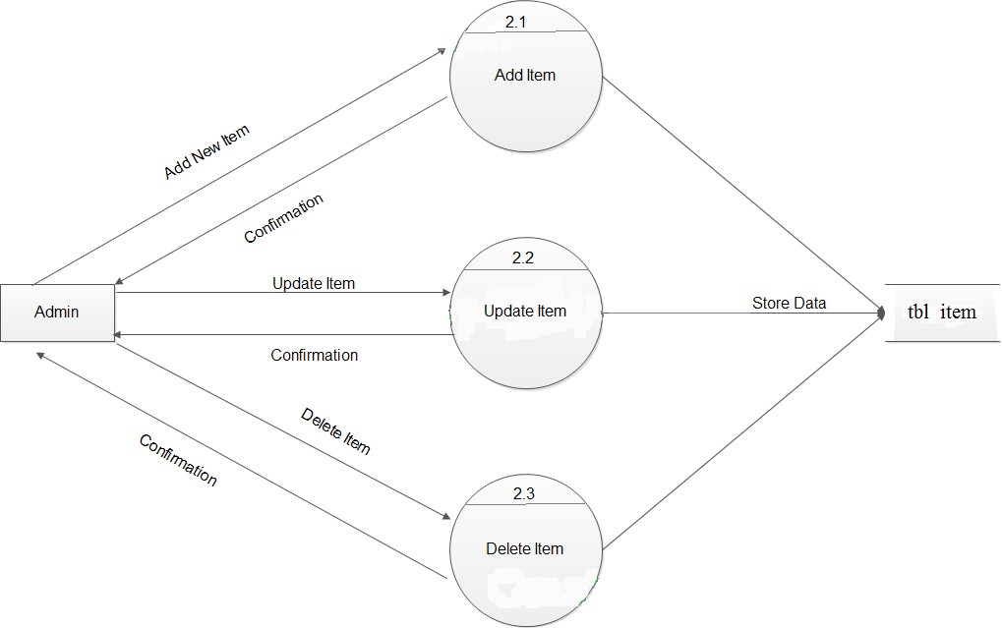

­­­­­

**6.CODING:**

**6.1 INDEX.PHP:**

<!DOCTYPE HTML>

<!--

BOOK SELLING

-->

<html>

<head>

<title>2ndHAND BOOK SELLING</title>

<meta charset="utf-8" />

<meta name="viewport" content="width=device-width, initial-scale=1" />

<link rel="stylesheet" href="assets/css/main.css" />

</head>

<body>

<!-- Header -->

<header id="header">

<div class="logo"><a href="">BOOK RESELLING <span>ALL OVER TAMILNADU</span></a></div>

<a href="#menu"><span>Menu</span></a>

</header>

<!-- Nav -->

<nav id="menu">

<ul class="links">

<li><a href="userlogin.html">USER LOGIN</a></li>

<li><a href="">ADMIN LOGIN</a></li>

<li><a href="">ABOUT WEBSITE</a></li>

</ul>

</nav>

<!-- Banner -->

<!--

Note: To show a background image, set the "data-bg" attribute below

to the full filename of your image. This is used in each section to set

the background image.

-->

<section id="banner" class="bg-img" data-bg="BK1.jpg">

<div class="inner">

<header>

<h1>online bookreselling</h1>

</header>

</div>

<a href="#one" class="more">Learn More</a>

</section>

<!-- One -->

<section id="one" class="wrapper post bg-img" data-bg="BK5.jpg">

<div class="inner">

<article class="box">

<pre></pre><h2>BEST PLACES TO SELL YOUR OLD BOOKS

AND

BUY OLD BOOKS</h2></pre>

</article>

</div>

<a href="#two" class="more">Learn More</a>

</section>

<!-- Two -->

<!-- Footer -->

<footer id="footer">

<div class="inner">

<h2>Contact Me</h2>

<form action="#" method="post">

<div class="field half first">

<label for="name">Name</label>

<input name="name" id="name" type="text" placeholder="Name">

</div>

<div class="field half">

<label for="email">Email</label>

<input name="email" id="email" type="email" placeholder="Email">

</div>

<div class="field">

<label for="message">Message</label>

<textarea name="message" id="message" rows="6" placeholder="Message"></textarea>

</div>

<ul class="actions">

<li><input value="Send Message" class="button alt" type="submit"></li>

</ul>

</form>

<ul class="icons">

<li><a href="#" class="icon round fa-twitter"><span class="label">Twitter</span></a></li>

<li><a href="#" class="icon round fa-facebook"><span class="label">Facebook</span></a></li>

<li><a href="#" class="icon round fa-instagram"><span class="label">Instagram</span></a></li>

</ul>

<div class="copyright">

&copy; Untitled. Design: <a href="">rks bookselling website</a>. Images: <a href="">Unsplash</a>.

</div>

</div>

</footer>

<!-- Scripts -->

<script src="assets/js/jquery.min.js"></script>

<script src="assets/js/jquery.scrolly.min.js"></script>

<script src="assets/js/jquery.scrollex.min.js"></script>

<script src="assets/js/skel.min.js"></script>

<script src="assets/js/util.js"></script>

<script src="assets/js/main.js"></script>

</body>

</html>

6.2HOME PAGE:



**6.3 MENU:**

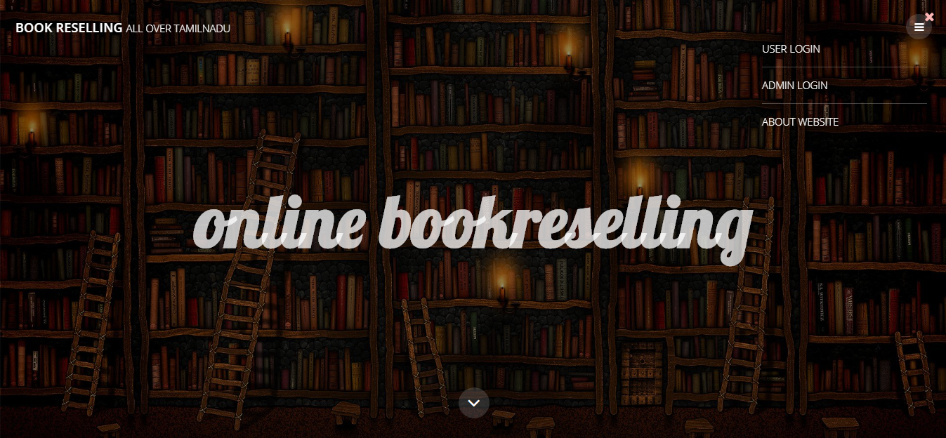

**6.4 LOGIN AND SIGNUP PAGE:**

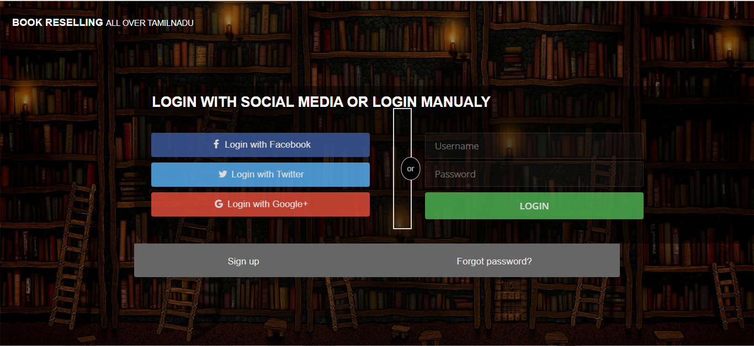

**7.Testing And Maintainance:**

### 7.1**TEST CASES:**

**7.1.1 HOME PAGE:**

* The home page is the first page that appears to the user in the website.
* Some test cases are generated as under:

|  |  |  |  |  |
| --- | --- | --- | --- | --- |
| **Steps** | **Inputs** | **Actual Result** | **Status** | **Remark** |
| 1 | Click on Home | It is a link to the Home page of the site | Fail | Look whether a link is provided to  the Home click |
| 2 | Click on Register Free | It is a link to the Signup page | Pass | None |
| 3 | Click on Log in | It is a link to the Sign in page | Fail | Look whether a link is provided to  the Sign in click |

**7.1.2REGISTER PAGE:**

* The sign up is the page that provides the authentication to the user
  + - * The user is allowed to fill a sign up form giving some information about himself .
      * Some test cases are generated as under:

**Test Case for Register Page**

|  |  |  |  |  |
| --- | --- | --- | --- | --- |
| **Steps** | **Inputs** | **Actual Result** | **Status** | **Remark** |
| 1 | Enter a Sign in id | Takes input for the Sign in id and displays Sign  in id entered | Pass | None |
| 2 | Enter password | Takes input for the password and displays password entered in  encrypted form | Pass | None |
| 3 | Enter confirm password | Takes input for the confirm password | Fail | Enter a matching  Password |
| 4 | Enter Name | Takes input for the name | Pass | None |
| 5 | Enter City | Takes input for the city | Pass | None |
| 6 | Enter Mobile | Takes input for the mobile | Pass | None |
| 7 | Enter Email | Takes input for Email | Pass | None |

**7.1.3 LOG IN PAGE:**

* + - * The sign in is the page that the user to authenticate himself for the website and use various resources and facilities
      * In the sign in page, the has to provide the username and password .
      * If he/she provides a valid detail , he/she is successfully logged in the site.
      * Some test cases are generated as under:

**Test Case for Sign In Page:**

|  |  |  |  |  |
| --- | --- | --- | --- | --- |
| **Steps** | **Inputs** | **Actual Result** | **Status** | **Remark** |
| 1 | Enter your  User name or Email id | Takes input for the user‟s Sign in id | Pass | None |
| 2 | Enter your password | Takes input for the password | Fail | Incorrect password has been entered, check for  capslock |
| 3 | Click on Sign in in button | The site is directed to the welcome page with you as a signed in user | Fail | Check for the credential the user  provided |

**8. DEPLOYMENT AND MAINTENANCE:**

After successful testing and validation of the application , the application needs to be made available to the users for implementation or use. Deployment is simply the implementation of the developed project on the client site.

The site as soon as hosted on the internet, the site becomes available to use .At first, when the user opens the site in a pc, he/she has to sign up for the site.

After he/she has signed up successfully, he/she will be able to appear for the various exams like VB, C, etc, he/she can maintain his/her account on the site.

**9.CONCLUSIONS:**

**9.1SUMMARY:**

The system was design in such a way that future modification can be done easily. The following conclusions can be deduced from the development of the project:

* + Automation of the entire system improves the efficiency.
  + It provides a friendly graphical user interface which probes to be better when compared to the existing system.
  + It gives appropriate access to the authorised users depending on their permissions.
  + It effectively overcomes the delay in communication.
  + Updating of information becomes so easier.
  + System security, data security and reliability are the striking features.

The system has adequate scope for modification in future if it is necessary

### 

### **9.2FUTURE SCOPE:**

* + The development of this project surely prompts many new areas of investigations. This project has wide scope to implement it in any ecommerce websites.
  + This project covers all functionalities related to Book Selling. Hence it can be implemented anywhere else after minute in a click
  + The sharing facility will be available only to the logged in users.
  + We are also planning to provide the user with the facility to define different themes of

# 10.REFERENCES:

1. The Unified Modeling Language Reference Manual - James Rumbaugh, Ivar Jacobson, Grady Booch- Addison Wesley
2. Database Management Systems-Third Edition (IE) - Raghu Ramakrishnan, Johannes Gerkhe, Mc Graw Hill Edition.
3. Software Engineering -K.K. Aggarwal and Yogesh Singh
4. Web Enabled Commercial Application Development -Ivan Bayross
5. Complete PHP Reference - [www.w3schools.com](http://www.w3schools.com/)
6. Comple javascript books reference-- <https://jsbooks.revolunet.com/>